STUDENT NO: ST10470570

Name: Roberto Carlos Dondo

Module: WEDE5020

PORTFOLIO OF EVIDENCE: PART 2

Lecture: MR Motau

Due Date: 05 May 2025

Table of Contents

Website Choose and Description 1

Business Description of Dondo Water NGO 1

Assets 1

Homepage 1

About Us 1

Services 1

News 1

Contact Us 1

General Styling Improvements Across All Pages 1

The Entire estimated budget 1

Bibliography 1

# Website Choose and Description

# Business Description of Dondo Water NGO

A non-profit organization called Dondo Water is dedicated to provide rural communities and people without access to clean drinking water dependable, sustainable clean water solutions. We enable these communities to enhance their general quality of life, health, and education by guaranteeing a consistent supply of water. Our goal is to establish a society in which everyone, everywhere, has access to safe, clean water, promoting growth, well-being, and new opportunities for everybody.

Through important projects including planning and constructing water delivery systems like boreholes, wells, and rainfall harvesting structures to ensure sustainable access to water, Dondo Water implements workable and long-lasting solutions to solve water scarcity in underprivileged communities. By offering and maintaining reasonably priced, low-maintenance filtration and purification systems, we guarantee the safety of the water. Additionally, we provide instructional programs on sanitation, hygiene, and water conservation to strengthen local communities. We seek to build sustainable water infrastructure and make the biggest effect in the places that need it most by working with regional administrations and global organizations.

Through quantifiable objectives, such as installing and maintaining water systems in 100 rural communities within the first five years, educating at least 10,000 people on best practices for hygiene and water conservation within the next two years, and forming alliances with NGOs, governments, and businesses to broaden our reach and guarantee long-term sustainability, Dondo Water is committed to creating a lasting impact. We measure the number of individuals served, the installation of water systems, and the advancements in economic and health results in order to monitor our success. We want to bring about significant, long-lasting change in marginalized areas by holding ourselves accountable.

We at Dondo Water think that having access to clean water is both a basic human right and a driving force for social and economic advancement. We work to create a future in which no community is left without this vital resource by consistently innovating and partnering with committed partners. We're still dedicated to growing our influence and changing lives via sustainable water solutions, with the help of funders, volunteers, and stakeholders. By working together, we can make it possible for everyone to have access to clean, safe water.

## Assets

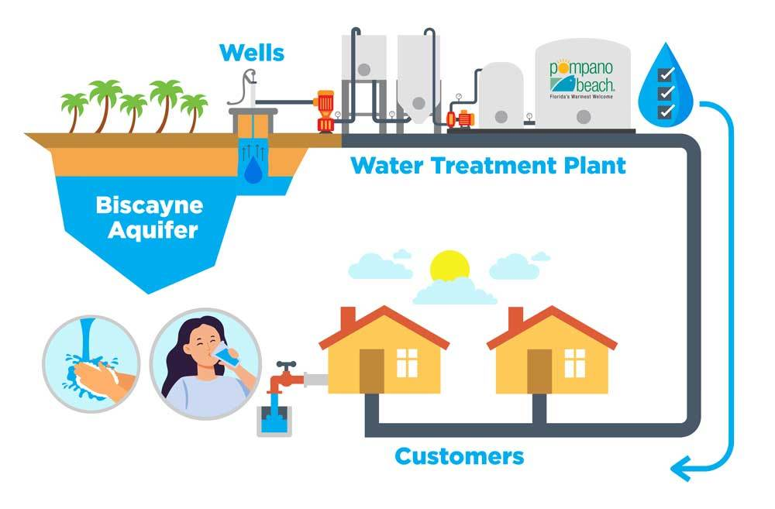

### Homepage

1. Page Heading: Welcome to Dondo Water
   * Styling: The main heading has an animated fade-in effect with a gradient color scheme of bright yellow and orange to capture attention. The font is bold and uppercase with a modern and dynamic look.
2. Links to other pages: (Home, About Us, Services, News, Contact Us)
   * Styling: Navigation links are styled with a teal background and white text, which turns to a dark teal on hover. They have smooth transitions and a scaling effect when hovered over.
3. Brief description of Dondo Water
   * Styling: Text appears with a fade-in animation, and is placed inside a well-structured, centered content box with rounded corners, shadows, and adequate padding for a clean look.
4. Vision of Dondo Water detailed
   * Styling: The vision text has a clean, centered alignment and a background that is slightly shaded to stand out. Font size and line-height are adjusted to make the content more readable.
5. Image of What We Do
   * Styling: Images are responsive with a border-radius for rounded corners. They smoothly scale up when hovered over for a more interactive feel.
6. Copyright/year
   * Styling: Copyright notice is centered and displayed at the bottom with light background color to not overpower the rest of the content.

### About Us

1. Page Heading: About Us
   * Styling: Similar to the homepage, the page heading has a bold, gradient animated effect that uses a combination of yellow and orange to grab attention.
2. Links to other pages: (Home, About Us, Services, News, Contact Us)
   * Styling: Navigation bar styling is consistent with the homepage, with clean, centered links and transition effects when hovered over.
3. Small introduction about Dondo Water
   * Styling: The introduction is placed in a highlighted box with a background color of light yellow and bold text for emphasis.
4. Information about what we can do together, our impact in South Africa, our promises to you, and donations
   * Styling: Impact data (such as funded projects, provinces served) is placed in unordered lists, which are indented for clarity. Donation call-to-action uses a bright yellow button styled with a smooth hover effect.
5. Image of About Us
   * Styling: The image here has the same styling as on the homepage, with rounded corners and smooth hover scaling.
6. Copyright/year
   * Styling: Consistent footer style as on the homepage.

### Services

1. Page Heading: Our Services
   * Styling: The main heading is styled similarly to the "About Us" page, with a bold and impactful font with a gradient color effect.
2. Links to other pages: (Home, About Us, Services, News, Contact Us)
   * Styling: The same navigation bar style is maintained across all pages.
3. Heading Core Services and descriptions of them with emojis included
   * Styling: Each service heading is highlighted in a bright yellow background with bold, dark text. Emojis are incorporated to visually represent each service, adding a friendly and approachable vibe.
4. Image of Our Services
   * Styling: The service images have a box shadow and rounded corners, and scale up when hovered over, adding interactivity.
5. Copyright/year
   * Styling: Consistent footer style with proper alignment.

### News

1. Page Heading: News
   * Styling: The news heading has a teal-colored font and a background of yellow to match the theme. It is bold, clear, and easy to spot.
2. Links to other pages: (Home, About Us, Services, News, Contact Us)
   * Styling: Navigation bar remains consistent, creating uniformity across pages.
3. News Description of Challenges faced by South Africa
   * Styling: The news description uses bolded headings for key points, with the content appearing clearly within a structured content box. It is laid out in paragraphs with good spacing for readability.
4. Image of News Showing a Mountain Describing the challenges we need to overcome
   * Styling: The image has the same rounded corners and hover effect applied as the other pages, with the transition adding subtle dynamism.
5. Copyright/year
   * Styling: Consistent with the other pages.

### Contact Us

1. Page Heading: Contact Us
   * Styling: The heading is bold and uses the same gradient style as the other headings for continuity.
2. Links to other pages: (Home, About Us, Services, News, Contact Us)
   * Styling: Navigation bar is consistent.
3. Contact Details: (Email, Phone, Location)
   * Styling: Contact information is clearly presented, with each piece of information easily distinguishable. The text color is teal to stand out, and the text alignment is centered.
4. Send us a Message option
   * Styling: The contact form is laid out neatly, with labels and input fields styled with soft borders, padding, and background colors. There is a hover effect on the send button that turns it a darker teal on hover.
5. Copyright/year
   * Styling: Standard footer with consistent look across all pages.

### General Styling Improvements Across All Pages

* Font: The website uses a modern sans-serif font ("Poppins"), giving it a clean and friendly feel.
* Color Palette: The website follows a cohesive color palette of teal, yellow, and orange. These colors are used in headings, navigation, buttons, and highlights.
* Animations: Several sections have animations such as fade-in and slide-up to enhance the user experience. These animations make the content feel more dynamic and engaging.
* Images: Images are responsive, with rounded corners and hover effects that add visual interest when users interact with them.
* Buttons: Call-to-action buttons (such as the donate button) are styled with a bright color and smooth hover transitions, encouraging user interaction.
* Layout: Content is organized into well-defined sections with clear headings, and padding and margins ensure readability and an aesthetically pleasing layout.

This structure improves the overall user experience by making the content more visually appealing, interactive, and cohesive across all pages of the website.

The Entire estimated budget

It ranges from R250,000 to R900,000, depending on scale and automation degree.

Operational Costs Per Month (After Launch)

Water, bottles, labels, utilities, and other production costs range from R50,000 to R200,000.

Advertising and Marketing: R5,000 to R20,000

Labor & Salaries: R30,000 to R100,000.

Delivery & Logistics: R20,000 to R80,000

Additional costs: R10,000 to R30,000

Monthly Operating Cost Estimate: R100,000 to R400,000

Important Elements Impacting the Budget:

Scale of Production: Although it costs more, automated bottling on a large scale is more effective.

Water Source: Although installing a borehole water system is more expensive, it saves money over time.

Purification System: Basic filtering is less expensive than reverse osmosis.

Marketing Plan: Compared to traditional media, digital marketing is less expensive.

Packaging Quality: Generic bottles are less expensive than custom-branded ones.

### Screenshot Evidence of the different screen sizes(desktop, tablet and mobile)

**Mobile**

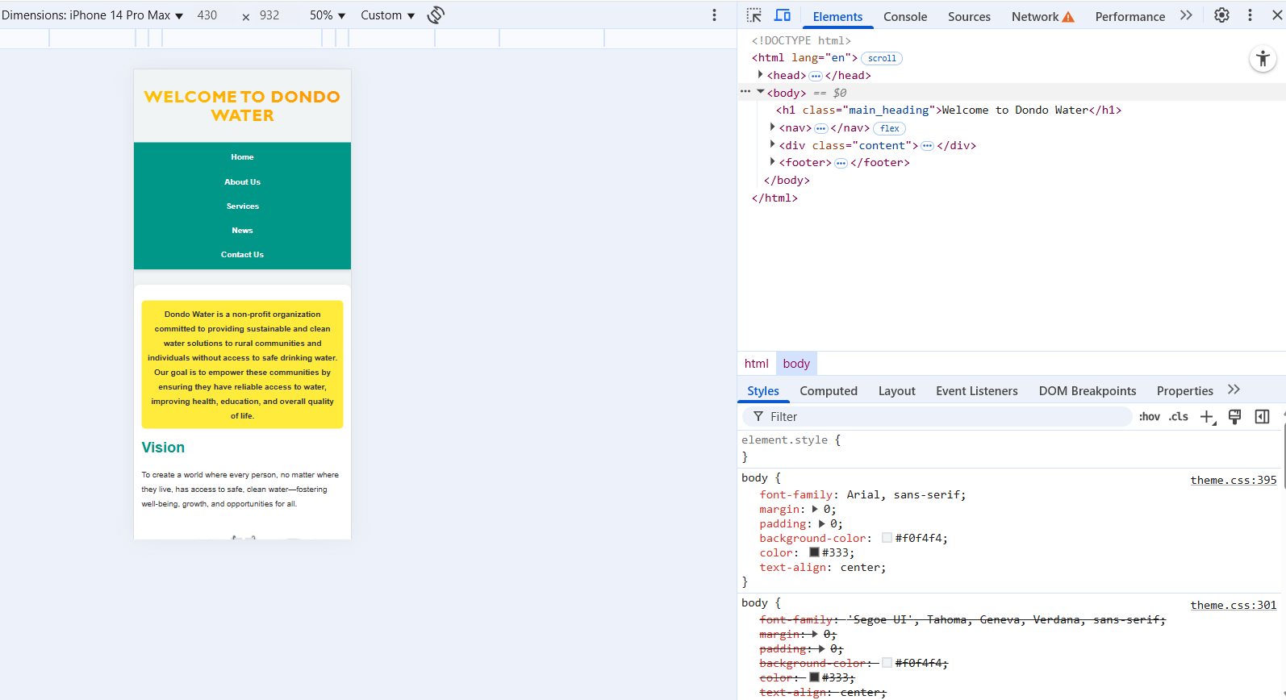

**Tablet**

**Desktop**

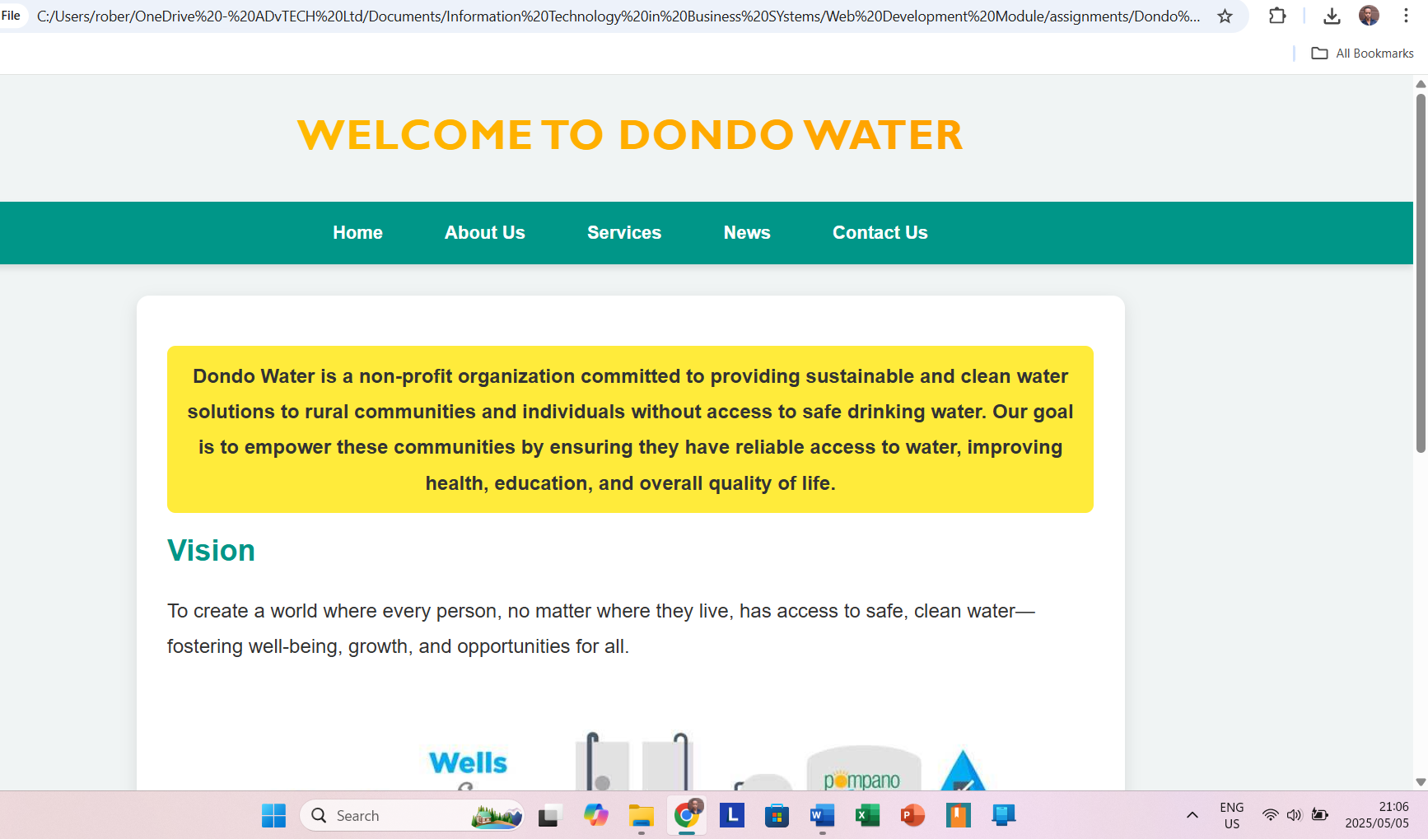

# Bibliography

Organisation, W. H. (2022). *World Health Organisation*. Retrieved from World Health Organisation: https://www.who.int/publications

S, H. (2019). *Thirst: A Story of Redemption, Compassion, and a Mission to Bring Clean Water to the World. Currency.*

Water, C. (2024). *Charity:Water*. Retrieved from Charity Water: https://www.charitywater.org